WEEK 3:

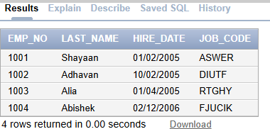

SOWBARNIGAA SRIDHARAN

230701327

create table dept2(emp_no number(10), last_name varchar(25), hire_date DATE, job_code varchar(25));

Begin

Insert into dept2(Emp_no, Last_Name, hire_date, Job_code) values(1001, 'Shayaan','01-02-2005','ASWER' ); Insert into dept2(Emp_no, Last_Name, hire_date, Job_code) values(1002, 'Adhavan','10-02-2005','DIUTF'); Insert into dept2(Emp_no, Last_Name, hire_date, Job_code) values(1003, 'Alia','01-04-2005', 'RTGHY' ); Insert into dept2(Emp_no, Last_Name, hire_date, Job_code) values(1004, 'Abishek','02-12-2006','FJUCIK'); End;

/

select * from dept2;

select distinct job_code from dept2;

select hire_date as.STARTDATE from dept2;

SELECT emp_no||' , '||last_name' , '||job_code' , '||hire_date' AS "THE_OUTPUT"

FROM dept2;

select last_name||' , '||job_code AS"Employees And Title" FROM dept2;